The university of Azad Jammu & Kashmir, Muzaffarabad


Name | Sakeena Bano
Roll NO | 2024-SE-29
Course Title | Software construction &Development
Lab | 03
Submitted to | Engr. Asma Javeid

Department of Software Engineering

Lab 3
Software construction &Development

- Objective
Purpose of this practical lab is to learn how UML sequence diagrams work and how they describe communication between different objects in a software application. It helps students understand the flow of information, the order of operations, and the responsibilities of different system components during a particular activity.

2. Introduction

Sequence diagrams are an important part of UML (Unified Modeling Language). They are used to explain how different objects communicate with each other over a period of time. These diagrams present interactions in a step-by-step manner and make complex system processes easier to understand.
A sequence diagram generally contains actors, objects, lifelines, message arrows, activation bars, and combined fragments. These elements help represent the complete flow of a system operation.

3. Question 1: ATM Cash Withdrawal Sequence Diagram

Description
This task focuses on designing a UML sequence diagram for an ATM cash withdrawal process. It explains the communication between the customer, ATM machine, bank server, bank account, and cash dispensing unit.

Work Performed

The withdrawal process begins when a customer inserts an ATM card into the machine. The customer then enters a PIN, which is forwarded to the bank server for authentication.
Once the entered information is verified, the ATM asks the customer to specify the required cash amount. The bank server checks the account balance to determine whether sufficient funds are available.
If the request is accepted, the account balance is adjusted, and the ATM dispenser releases the requested cash. At the end, the machine displays a successful transaction message and returns the ATM card.
The diagram also includes unsuccessful conditions. For example, if the PIN is invalid or the account does not contain enough money, the withdrawal request is declined and the ATM displays an error notification.

UML sequence diagram
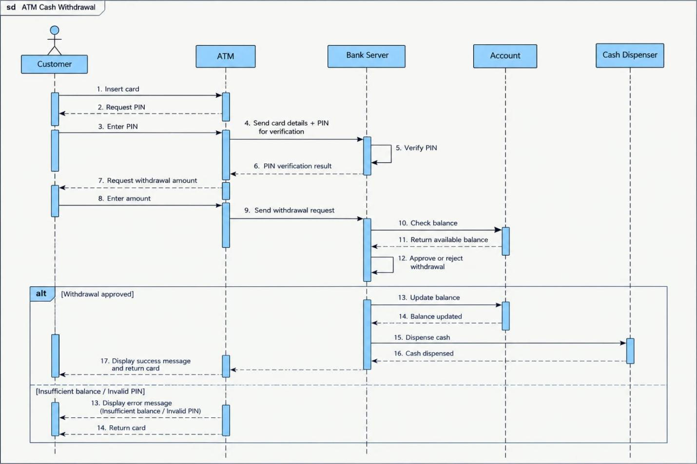
4. Question 2: Online Ticket Reservation System

Description

In this activity, a sequence diagram is developed to explain the working of an online ticket booking application. It demonstrates the interaction between the user, booking platform, availability database, and payment gateway.

Work Performed

First, the user accesses the online booking application and searches for available tickets. The system retrieves the required information from its database and presents the available options.
After selecting a suitable ticket, the customer provides the necessary booking information. The application forwards the payment details to the payment gateway for processing.
The payment gateway checks the transaction and sends its response back to the booking system. When the payment is approved, the system generates a ticket and provides the user with a booking confirmation.
However, if the payment is unsuccessful, the application informs the customer that the reservation could not be completed.

UML sequence diagram

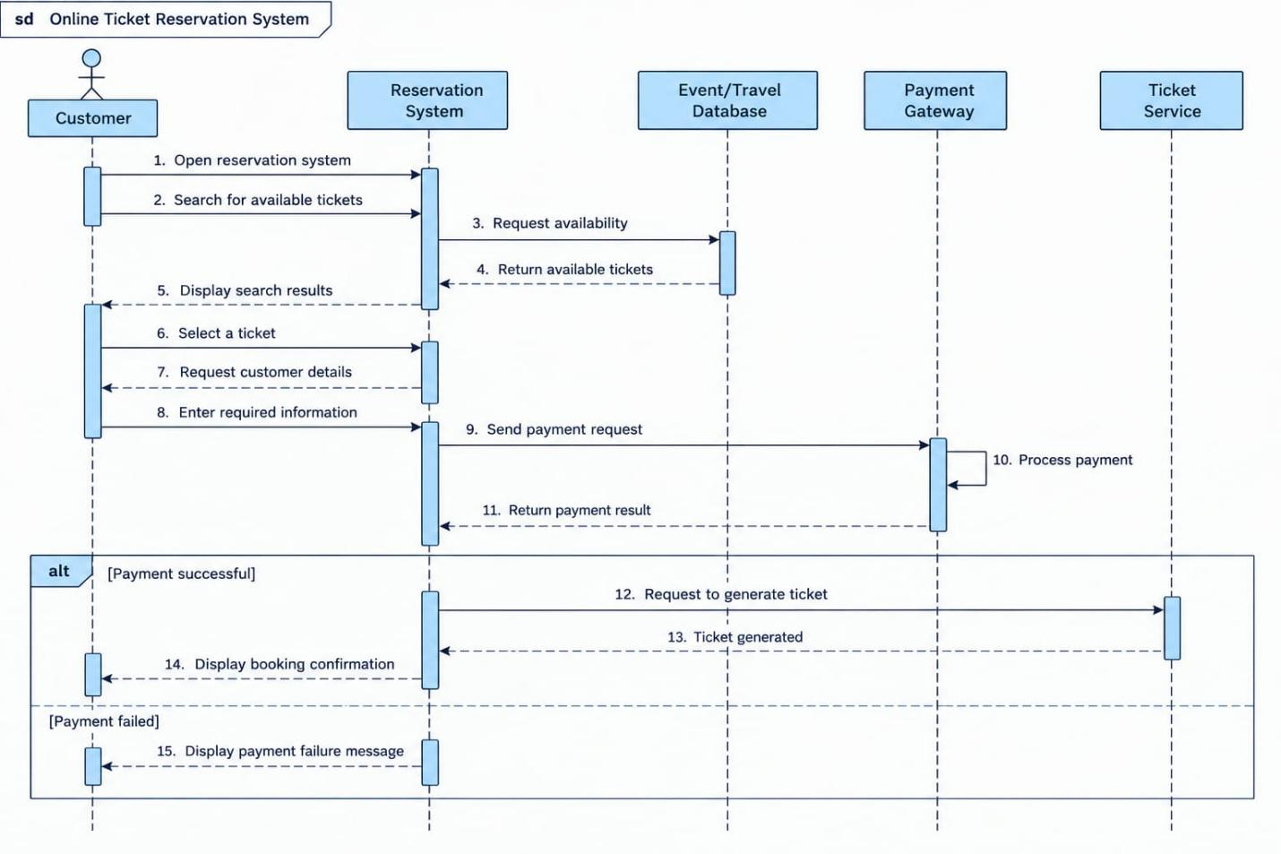

5. UML Symbols Used

The following elements are commonly used in UML sequence diagrams:
1. Actors and Participants: These represent users, external entities, or objects that take part in a system interaction.
2. Lifelines: Vertical dashed lines that indicate the existence of participants during a process.
3. Message Arrows: These illustrate the communication and requests exchanged between objects.
4. Return Messages: They represent the responses provided after receiving a request.
5. Activation Bars: These show the time during which an object is executing a particular task.
6. Alternative Fragment (ALT): This element represents different possible conditions and outcomes within the same process.

6. Conclusion

Through this practical activity, I gained knowledge about UML sequence diagrams and their importance in software development. I designed two diagrams representing ATM cash withdrawal and online ticket booking operations.
This lab helped me understand how objects exchange information, how system activities follow a specific order, and how different conditions can affect the final result. It also improved my ability to represent software functionality through graphical models.

